I
FORTHCOMING EVENTS
04-04-2007
Executive Committee Meeting 14-04-2007, 09.30 hrs A.G.M.
14.04.2007, 10.30 hrs
12th Annual Day Celebration
FOR KIND ATTENTION
P.S. Santhanakrishnan,
SBM (Retd.) (Finance &-Banking)
Prakasli H. Lullah,
(Personal Administration)
Dr. T.S. Kanaka,
M.S. M Ch (Health & Medicare)
Sudha Ramalingam,
P.0 C.L. (Legal. Law & Order)
Prof. Dr. V. Balambal,
(Educational, Social & Culture)
Dr. P.K. Ponnuswamy,
IFS (Retd.) (Civic Affairs)
M.D. Vijayarangam, B.E. R. Seshadri, B.Sc..
Special Committee Members: R. Venkatesan. IA&AS, (Rtd.) S.P. Ambrose, IAS (Rtd-)
Prof. Gomathy Narayanan K.P. Mahalingam, FIE T.V. Hariharan, FIE A. Sivasankaran, FIE Kousalya Sarathy
Past Presidents : Gen. Aban Naidu,
PVSM.AVSM
V Hariharan, FIE
SENIOR CITIZENS BUREAU Chairman Emeritus
Gen. Aban Naidu,
PVSM, AVSM
Chairman:
Dr. V.S. Natarajan,
MD. FRCP, DSc (Hon)
Vice Chairmen :
N. Subramanian, IRS (Rtd.) K. Lakshmikanthan
Bharathi IAS (Rtd.)
Secretary General
Capt. M. Singaraja, C. Eng.
Secretaries I-
S_ Murugaiyan, B.E. S. Esakkimuthu
Treasurer :
S.K. Vasudevan, B.A.,
Members and Journal subscribers are requested to renew Immediately their annual subscriptions for the year 2007-08, which become due in April 2007, to maintain the continuity of the communication.

Capt. M. Singaraja
Secretary General Ph- 94441 27704
Cordially invites you with your spouse for the
12" Annual Day Celebration
At 10-30 hrs on Saturday, the 14^{11,} April 2007,
at Sindhi Model Senior Secondary School
No. 1 Damodaran Street, Kellys, Chennai - 10.
(Near the Junction of Old lJma Theatre)
Hon'ble Justice A.S. Venkatachalamurthy
(Chairman, TN State Human Rights Commission, Chennai)
Will be the Chief Guest
Thim K.N. Krishnamurthy
(Technical Advisor, to M.D. Ashok Leyland and
National Immediate Past President, NIQR, Chennai)
AND
Thiru Lachmandas Khushiram,
(Chairman, Sindhi Model Senior Secondary School, Kellys, Chennai) Will be the Guests of Honour
General Aban Naidu, PVSM,, AVSM, M-In-D
(Chairman Emeritus, SCB & GOC, Delhi, Retd.)
Will preside over.
Your august presence is solicited.
Invitation | SENIOR CITIZENS BUREAU

26411938
26443713
22230935
25352459 24838806 24832186
26216767 26261332
24997977 24916494 24833813 26411577 22327009 24748156 28551943
26425555 26201011

24732943
26412030
26425555
Executive Committee Members :

141111110.
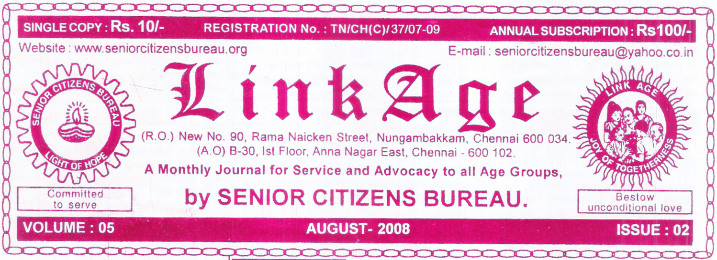
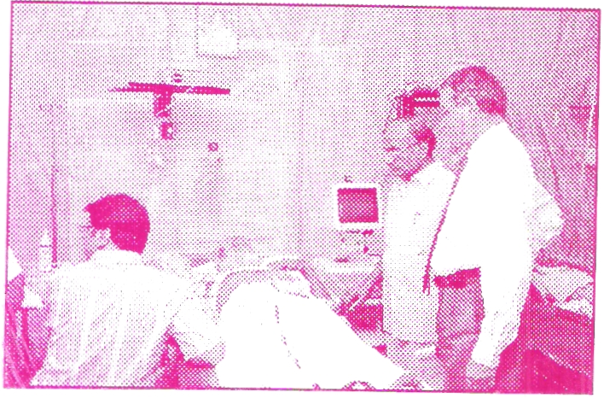

Dr VS Natarajan
Chairman
Ph: 2641 20')0
24996905 26216451
28231388
26502424 26282905
- Any other subjects of which due notice is given to the Secretary General
- Filling up of vacancies, if any.
- Appointment of auditor and fixing remuneration for the ensuing year
All the members are requested to make it convenient to attend.
Annual Day Celebration will follow immediately. -:1-
SECRETARY GENERAL Dated 20-03-2007
Notice is hereby given that the 5th Annual General Body meeting of Senior Citizens Bureau will be held at 0930 hrs. on 14-04-2007 ( Saturday) at Sindhi Model Senior Secondary School, No.1, Damodaran street, Kellys, Kilapuk, Chennai – 10. (near the junction of Old Uma Theatre)
The following items of business will be transacted :-
- Adoption of the minutes of the lastAGM
- Presentation and adoption of Annual Report
- Presentation and adoption Annual Account
- Amendment to byelaws of the Bureau
A.G.M. Notice | SENIOR CITIZENS BUREAU

BMD Test underprogress
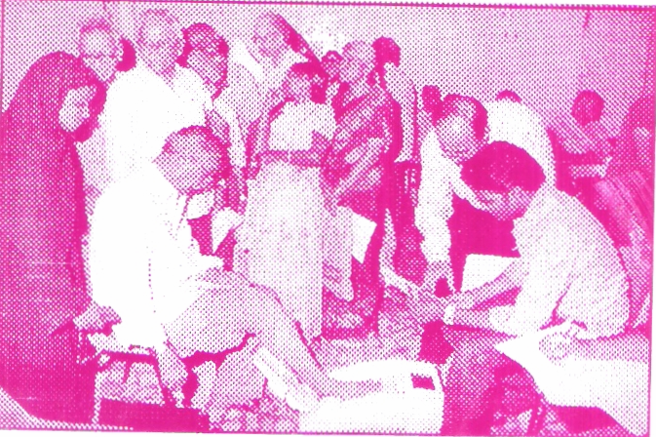
Ultrasonogram anderprogress
- Geriatrician, Psychologist and Geriatric Physiotherapist advice
Totally 70 persons attended the camp and received medical advice.
Volunteer members of the Bureau Tvl. SKD Murthy (AM 265), M. Subbian (AM 266) V. Murugan (AM 442) and volunteers of the AHI (Anjuman – E. Himayath.E.
Islam) Academy for Women, T.Nagar, Chennai 17 assisted the Office Bearers and looked after the arrangements.
E.C. MEETING
In the E.C. Meeting held on 14-2-2007 it was decided to create endowment for instituting awards and to evolve projects for the benefit of weaker sections. v
Senior citizens bureau, in association with CIPLA ltd. organized a camp for urinary incontinence, which is common for both men and women.
The camp was held on 24-03-2007 ( Saturday) at Kumaran Hospital , Kilpauk, Chennai –10.
The following specialists and investigations were provided by the team headed by Dr. V.S. Natarajan,, Geriatric Physician.
- Urology Assessment for Males and Females by urologist & Urogynaecologist
- BMD Test
- Utrasonogram KUB/PELVIC region.
- Random Blood Sugar
- Height. Weight, Body Mass Index and BP
Activities | CAMP ON URINARY INCONTINENCE FOR OLDER ADULTS  56th Elder Welfare Programme

i - 2 April 2007 LinkAge
^{t} -/A monthly journal of Senior Citizens Bureau
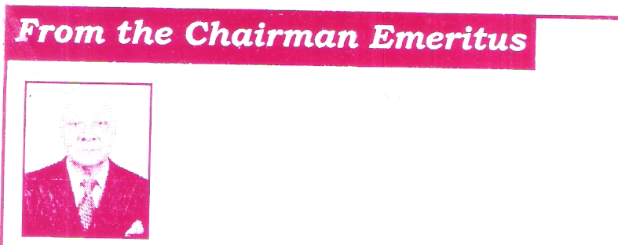
Website
TO KNOW MORE ABOUT
GERIATRIC^{I}AN, GERIATRIC MEDICINE & GERIATRIC SERVICES
Visit the website'.
www.geriatricsdrvsn.com
(Dr. V.S. Natarajan,
Geriatric Physician & Chairman, Senior Citizens Bureau)

~11~ 11
Mr. C. Sarvotham Rao, IFS (Retd) President / the Association of Retired Forest Officers Andhra Pradesh, Hyderabad writes " Hearty Congratulations and greetings on your nominations to the N.C.O.P. by the Govt. of India. Your field of activity now extends to the entire nation and all the over 80 million elders look to you for focusing
Rtinn's attention towards their problems and welfare.
Mail Box
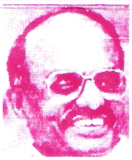
Urinary incontinence is a very common problem among older people and can greatly reduce a person's quality of life. Urinary incontinence is not part of normal ageing although ageing g chanes may predispose to its occurrence. Most cases of incontinence can be cured or at least improved.
Every person with incontinence is entitled to evaluation and consideration for treatment. Healthcare providers should be prepared to ask their patients about urinary incontinence and to treat it when it is present- Development of medical and nursing school curricula on this topic is urgently needed and more research is required to improve assessment and treatment.
ETIOLOGOIES OF THE TYPES OF INCONTENENCE
URGE (Detrusor Hyperreflexia)
- Local irritation ( infection, stones, tumour)
- Damage to cortical inhibitory centers ( CVA, PD, AD)
OVERFLOW (Detrusor hyporeflexia)
- Neurogenic
- Chronic obstruction
STRESS (Outlet resistance too low):
- Pelvic floor laxity
- Trans Urethral Resection of Prostate (TURF')
URGE FOLLOWED BY OVERFLOW
(Outlet resistance too high):
- Males. Benign Hypertrophy of Prostate (BPH), post TURP fibrosis, fecal impaction, stricture
- Females: Cystocele, urethral fibrosis, fecal impaction, pelvic mass.
patients and under-treated by
physicians.
- There are four basic types of urinary incontinence: Stress, Urge, Overflow, and Functional.
- Simple testing can identity the type
of urinary incontinence present.
- Treatment of incontinence must be tailored to correct the specific etiology underlying the specific type of incontinence.
- Most incontinence is curable. And
all incontinence is treatable.
- Urinary incontinence is a very common problem.
- U r i n a r y incontinence is under-reported by
From the Chairms, n
INCONTINENCE OF URINE
Dr.V.S. Nataraian, MD, FRCP (Edin), D.Sc., (Hon)
camp and consequently learning some aspect of their profession.
They moved freely with elders and other nursing staff, without any difference of caste, creed or religion.
After all, health care is universal and has no bar to human suffering. All are equal and there is only one caste, the Caste of Humanity. There is only one religion, the Religion of Love. Whether these young people followed this principle nciple knowingly or unknowingly, I dare say, this is some thing great
We talk of national integration, communal harmony and so on. Here we see in this small example, a REALITY._ I wish that this spreads to all humanity, society and the nation. God Bless. h -.0.
attendance, waiting for their turn for examination.
Besides the core group of Senior Citizens Bureau, there were voluntary nursing staff from Kumaran Hospital School of Nursing, assisting , guiding and helping the elderly to each of the station for various examinations / tests. There was an orderly and smooth flow of men and women taking their tests. The elderly were most happy and indeed gratified for the quality and personalised examination of the tests available under one roof.
While this be so, I was really pleased to see young Muslim girls in their uniform burkha of AHI Academy for Women, undergoing nursing training deputed to the camp for their exposure to medical camp and also rendering assistance as volunteers. I interacted with many of them. They were enthusiastic, sincere and happy to be associated with the medical

group, assisted by Medical specialists
conducts every month a Medical Camp for the elderly. On Saturday: 24th March 2007, the camp was held for a mult^{i} purpose examination /test involving.
- Urology Assessment for Males and Females
- Utrasonogram KUB/Pelvic Region.
- Random Blood Sugar
- Height, Weight, Body Mass Index and BP
5 Geriatrician, Psychologist and
Geriatric Physiotherapist advice
There were about 100 elderly people in
As is customary for the Senior Citizens Bureau under the patronage of Dr. V.S. Natarajan, Capt. M. S i n g a raja, S. Murugaiyan and core

SERVE HUMANITY WITH LOVE
Gen. Aban Naidu, PVSM. AVSM. M-in-D.
A monthly journal of Senior Citizens Bureau —
0
April 2007 •,*• LinkAge
•
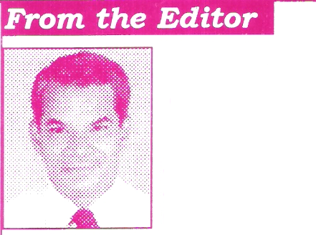
LinkAge
TO
Published by Eng.Capt, M. Singaraja on behalf of Senior Citizens Bureau, (R.O.) New No.90, Rama Naicken Street,
Nungarnbakkaim Chennai - 600 034. Ph : 2823 1388. Printed by Srikalaivani at Sri Maruthy Laser Printers. 173, Peters Road,
Royapettali. Chennai - 600 014. Ph ..- 2852 4256. Editor : Capt. M. Singaraja, C.Eng. Secretary / Publication : Eng. S. Murugaiyan.
If. undelivered please return to
SENIOR CITIZENS BUREAU
(A.0.) No., B-30, 1st Floor, Anna Nagar (East), ,Chennai - 600 102. Ph : 2628 2018, 28231388
C4' April 2007 -*.- LinkAge
A monthly journal of Senior Citizens Bureau
Published in the Second Week of Every Month Licenced to post w/o prepayment vide WPF No.41/07-09
Birthdays/ 16th April -15th May
IWISHING YOU A CHEERFUL AND PEACEFUL
.No. DOB  emb.No. |  | LONG LIFE.  Name
1 | 16-04-1933 | P.V.R. RAJA | LM | 088
2 | 17-04-1945 | C.PANNEERSELVAM | AM | 027
3 | 17-04-1922 | G.SUNDARARAJAN | AM | 123
4 | 19-04-1939 | VRAMAKRISHNAN | AM | 306
5 | 19-04-1939 | M.MAHADEVAN | LM | 160
6 | 27-04-1914 | C.BALASUBRAMANIAN | AM | 111
7 | 29-04-1935 | K.R.NARAYANAN | AM | 115
8 | 29-04-1934 | C.Sl VSU BRAMAN IAM | AM | 136
9 | 05-05-1939 | R. PALANICHAMY | AM | 073
10 | 05-05-1935 | M.RAJALAKSHMI | AM | 110
11 | 06-05-1942 | T.G. RAJENDRAN | AM | 415
12 | 07-05-1936 | K.R.NARAYANAN | AM | 115
13 | 07-05-1936 | S.NARASIMHALU | LM | 139
14 | 07-05-1937 | S. ESAKKIMUTHU | AM | 370
15 | 10-05-1939 | DR.VIMALARAJAPPA | LM | 463
16 | 10-05-1954 | R.RADHAKRISHNA RAJA | AM | 230
17 | 12-05-1939 | P.APPA RAO | AM | 319
18 | 12-05-1924 | S.V.IYER | LM | 367
19 | 15-04-1924 | DR.KAMAKHISUNDARAM | LM | 016
20 | 15-04-1937 | N.S. RAJAGOPALAN | AM | 414
21 | 15-05-1941 | M.SANKARAN | AM | 069

GOD BLESS YOU
National" - as-International I Days : April. .'
01 -ALL FOOLS DAY, 05- NATIONAL MARITIME DAY(N), 07-WORLD HEALTH DAY, 08 -SAFE MOTHERHOOD DAY, 11- NATIONAL SAFE MOTHER HOOD DAY(N),18 - WORLD HERTAGE DAY, 21 - CIVIL SERVICESDAY(N), 22 -WORLD EARTH DAY 23- BOOK& COPYRIGHT DAY, 30 - ANTI CHILD LABOUR DAY
We welcome new members to- mfly-jbld-
S.Na Name & Membership No | DOB. | Post held | Phone
1 Di. Ayesha Harnid LM 478 | 24.01.1948 | Doctor | 28363256
2 Mr. G.B. KrishnaAM 479 | 21,01.1936 | Ho^{p} & Co. | 24890489

Out of 14 such days during March, I would like to draw Your attention to World Women's Day (8th), World Consumer Rights Day (15th) World Disabled Day (19th), Elimination of Racial Discrimination Day (21st) and Water Day (22nd) , the issues of which are threats to the prosperity of humanity. They need impolitical and single minded resolution to eliminate conflicts.
Unscrupulous Politicans and vested interests fuel the differences for their own ends. Most of the print and electronic media, irrespective of medium of language are interested in sensational news coupled with glamourous and commercial hypes,
Flesh (Model) exhibits, Pop. Shows, Product Launches, Fashion Parades, Non-sense advertisements and cricket mania, pollute our social values and ethics. They tend to create an entirely new culture which are Irrelevant to our youth, all in the guise of some thing new and different. The written langauge also is going to back seat. The social issues referred above do not find adequate coverage. The society, the Youth in particular are not sensitised to the level required.
Cricket for example has been hyped by media for money and power. It has marginalised the space, encouragement and the spirit in respect of other sports and games. The glamour, gamble and the fight are in full swing in every strata, cricket boards and players. Let US hope that the media reverse the trend sooner and prove
their social responsibility.
GLAMOUR AND COMMERCE
Capt. M. Singaraja, B.E., PGD13M., FIE., FIV.,
You may appreciate that "LinkAge" carries International and National Days, every month in the last page, to signify the importance of the designated days and related themes.
^{r}RNI Regn.No. TNENG/2004/13996
Postal Regn. RNP No. TN/CH (9 37/07-09.
Posted at Patrika Channel, Egmore RMS on 07-04-07

